CSE 4208: Computer Graphics Laboratory

**A Restaurant’s Multipurpose Kitchen**

By,

Doniel Tripura

Roll:1907121

Date of Submission: 26-01-2025



Department of Computer Science and Engineering

Khulna University of Engineering & Technology

Khulna 9203, Bangladesh

**Contents**

1. Introduction
2. Objective
3. Project Idea
4. Project Overview
5. Methodology
6. Key Features
7. Limitations
8. Discussion
9. Conclusion

**Introduction**

The "Restaurant's Multipurpose Kitchen" project is an innovative and creative computer graphics lab project designed to showcase the potential of 3D modeling and texture mapping. The project aims to simulate a realistic and functional kitchen environment for a restaurant, complete with essential furniture, appliances, and aesthetic features. By integrating advanced graphic techniques and realistic textures, this project brings the concept of a multipurpose kitchen to life in a visually appealing and immersive way.

**Objectives**

The objectives of this project are,

1. To create a visually detailed and realistic 3D model of a restaurant's kitchen.
2. To implement texture mapping techniques for a lifelike representation of surfaces and materials.
3. To simulate functionality and organization within the kitchen environment.
4. To demonstrate the use of various computer graphics techniques such as modeling, lighting, and rendering.
5. To develop a project that integrates both aesthetic appeal and practical design elements.

**Project Idea**

The idea behind the "Restaurant's Multipurpose Kitchen" is to design a comprehensive kitchen space that is not only visually appealing but also functionally optimized. The project integrates various elements such as a fridge, showcase, oven, seating arrangements, and a unique waterfall feature to create a dynamic and immersive environment. By using texture mapping for realistic representations of materials like grass, wood, and metal, the project aims to deliver an engaging experience that combines functionality with creativity.in building immersive and visually engaging simulations for architectural visualization and interior design.

**Project Overview**

The "Restaurant's Multipurpose Kitchen" project comprises multiple key components:

* **Furniture and Fixtures:** A seating table, chairs, and a showcase to display items.
* **Appliances:** A fridge and an oven, modeled to represent their real-world counterparts.
* **Decorative Features:** A waterfall element to enhance the aesthetic appeal.
* **Environment Textures:** Grass, road, wall color, roof color, floor color, wood, and fridge colors are applied using texture mapping for realism.

The project emphasizes both functional design and visual creativity, making it a standout representation of a professional kitchen space.

**Methodology**

1. Conceptualization: Planning the layout and features of the kitchen, including appliances, furniture, and decorative elements.
2. 3D Modeling: Using computer graphics tools to create 3D models of the fridge, showcase, oven, seating table, chairs, and waterfall.
3. Texture Mapping: Applying realistic textures to surfaces, such as grass for outdoor elements, wood for furniture, and metal for appliances.
4. Lighting and Rendering: Implementing appropriate lighting effects to create a realistic and immersive environment.
5. Optimization: Refining the models and textures for smooth rendering and performance.

**Keyboard Functionalities**

The project implements the following keyboard functionalities to provide an interactive and immersive control experience:

**Camera Movement**

* W: Move the camera forward.
* S: Move the camera backward.
* A: Move the camera left.
* D: Move the camera right.
* E: Move the camera upward.
* R: Move the camera downward.
* Camera Rotation
* Right: Rotate the camera upward (Pitch Up).
* Left: Rotate the camera downward (Pitch Down).
* Up Rotate the camera left (Yaw Left).
* Down: Rotate the camera right (Yaw Right).
* Page Up: Roll the camera counterclockwise.
* Page Down: Roll the camera clockwise.

Lighting Control

* 1: Toggle the directional light on/off.
* 2: Toggle Point Light 1 (on/off).
* 3: Toggle Point Light 2 (on/off).
* 4: Toggle Spotlight (on/off).
* Lighting Property Adjustments
* 5: Toggle ambient light for point lights.
* 6: Toggle diffuse light for point lights.
* 7: Toggle specular light for point lights.

Camera's position is constrained within predefined bounds.

* Special Features
* G: Toggle fan rotation and activation.
* ESC: Close the application window.

**Features**

**Realistic 3D Modeling**:

* **Comprehensive Design:** Includes essential kitchen elements such as a fridge, oven, and seating arrangements.

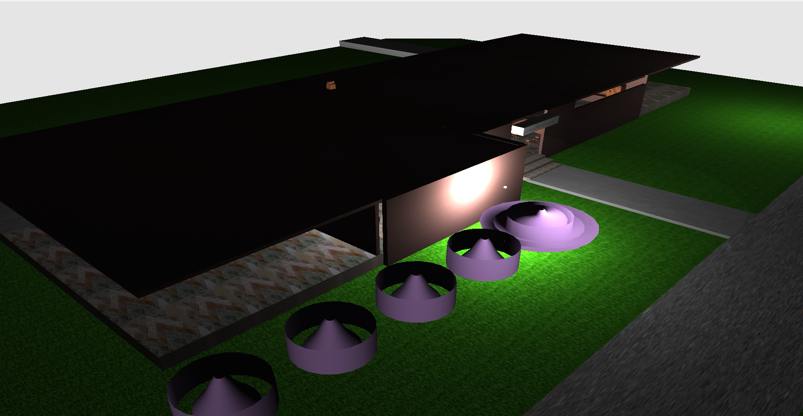

Figure 1: 3D Complete View of the restaurant

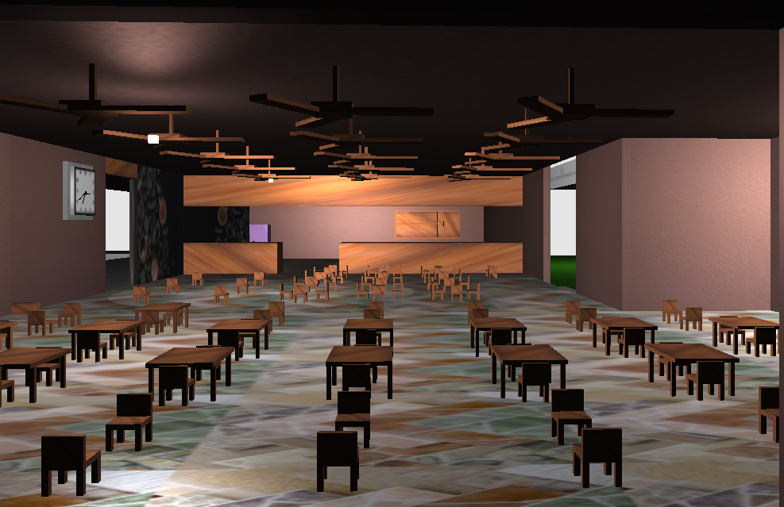

Figure 2: Entire View

* **Texture Mapping:** Realistic textures for various surfaces, including grass, wood, wall color, and roof color.



Figure 3: Wood texture for chair and table

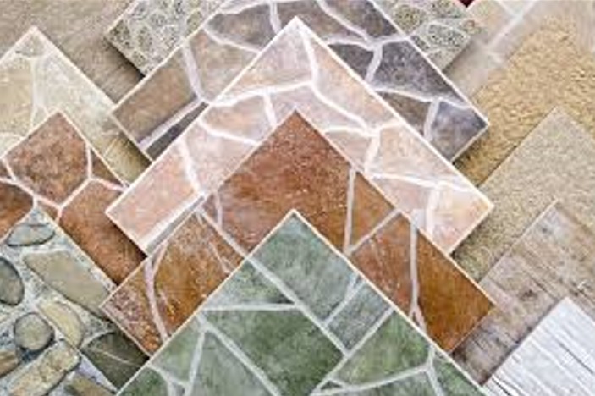

Figure 4: Floor texture

* **Aesthetic Appeal:** Features like a waterfall add uniqueness and enhance the visual experience.
* **Functionality Simulation:** Appliances and furniture are designed to be practical and organized within the kitchen space.

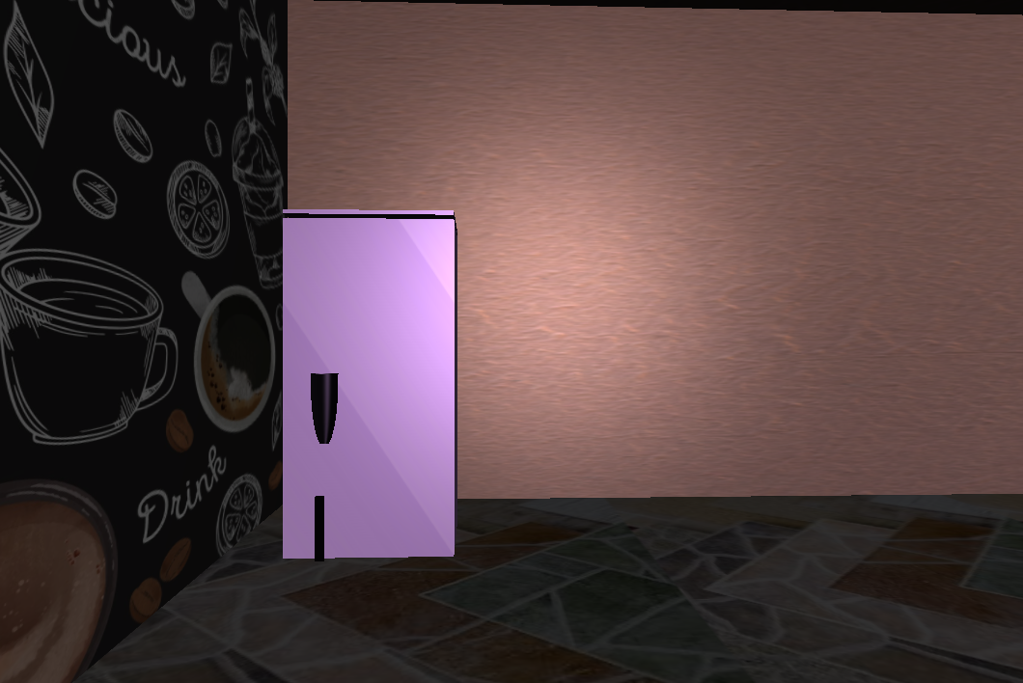

Figure 5: Fridge View

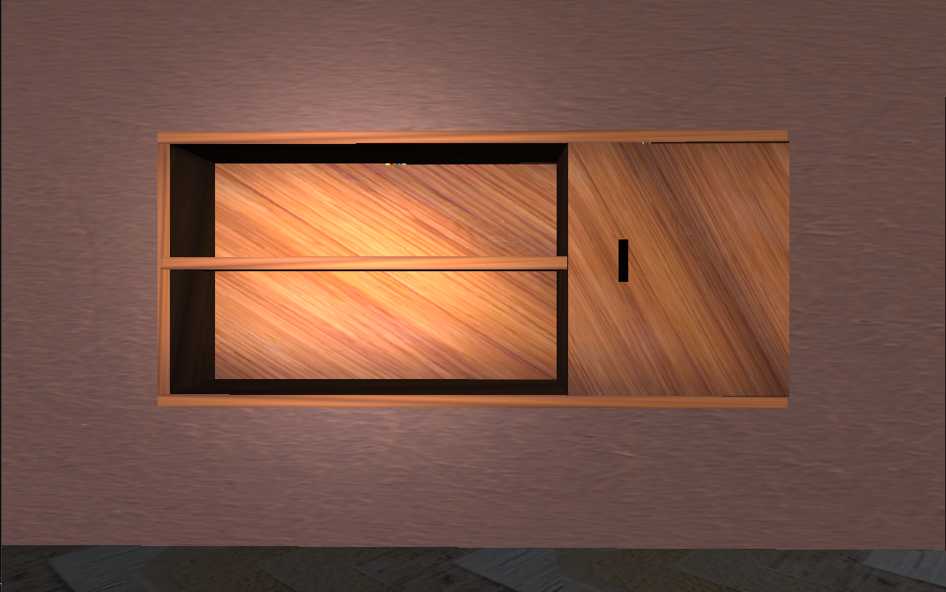

Figure 6: Showcase View

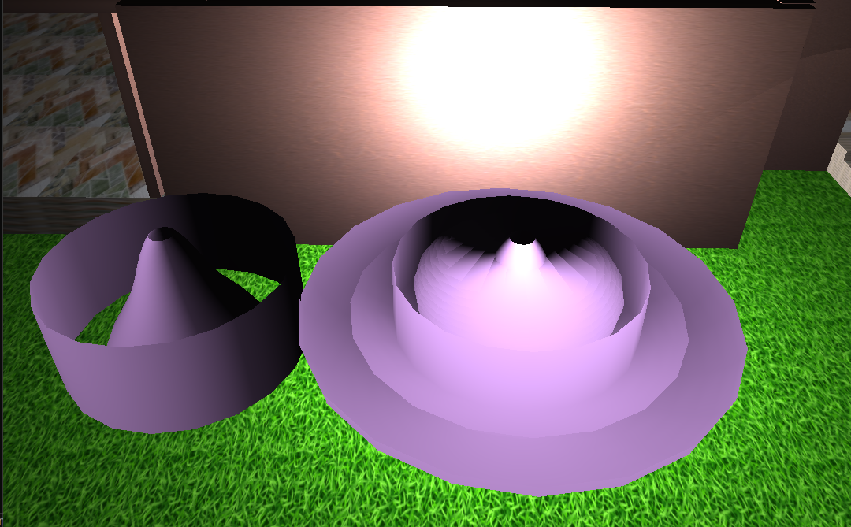

Figure 7: WaterFall using Bezier curve

* **Realism:** Lighting and rendering techniques are used to achieve a realistic and immersive environment. Use of geometric primitives like cubes, cylinders, spheres, and trapezoids for object modeling, ensuring a balance between visual detail and computational efficiency.

**Discussion**

The "Restaurant's Multipurpose Kitchen" project highlights the intersection of creativity and technical proficiency in computer graphics. By combining realistic 3D modeling, texture mapping, and rendering techniques, the project demonstrates the potential of computer graphics to simulate real-world environments with accuracy and artistic flair.

A significant achievement of this project is the effective use of **texture mapping**, where textures like grass, wood, and various surface colors contribute to the realism of the kitchen environment. The attention to detail in the design of essential kitchen appliances, furniture, and decorative elements like the waterfall adds to the project's aesthetic and functional value.

**Conclusion**

The "Restaurant's Multipurpose Kitchen" project successfully demonstrates the application of computer graphics principles to create a realistic, functional, and visually appealing environment. By incorporating key elements such as furniture, appliances, and decorative features, the project balances aesthetic appeal with practical design. The use of texture mapping for materials like grass, wood, and metal enhances the realism and visual depth of the kitchen.